

Dr. Joseph, Paul inc.
2024-04-13
Dr. Paul
456 Thompson Port Apt. 291, South Madison, PR 54653
Phone: 7170398464
Fax: 4310722510

Re: Kimberly, Perez
PHN: 1391377581
Birthdate: 21-Oct-1996
Address: 80515 Phillips Crossroad Apt. 876, Michellebury, NH 43430
Patient number: 7766660497

To Whom It May Concern:

This is a medical letter to state the above patient is pregnant with expected delivery date of 01-May-2025. Hoping this information is satisfactory for your requirements.

Thank you.

Sincerely,
Dr. Joseph, Paul
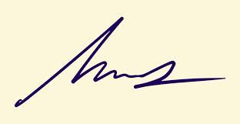
FRCS© NCMP
Clinical Assistant Professor, UBC
Department of Obstetrics and Gynecology SMH

